**Investigation:** Measuring Enzyme Activity in Yeast Spheres

AP Biology

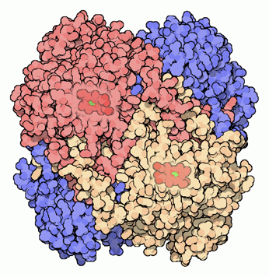

**INTRODUCTION**

Many organisms can decompose hydrogen peroxide (H2O2) enzymatically. Enzymes are globular proteins, responsible for most of the chemical activities of living organisms. They act as *catalysts,* substances that speed up chemical reactions without being destroyed or altered during the process. Enzymes are extremely efficient and may be used over and over again. One enzyme may catalyze thousands of reactions every second. Both the temperature and the pH at which enzymes function are extremely important. Most organisms have a preferred temperature range in which they survive, and their enzymes most likely function best within that temperature range. If the environment of the enzyme is too acidic or too basic, the enzyme may irreversibly *denature*, or unravel, until it no longer has the shape necessary for proper functioning.

H2O2 is toxic to most living organisms. Many organisms are capable of enzymatically destroying the H2O2 before it can do much damage. H2O2 can be converted to oxygen and water, as follows:

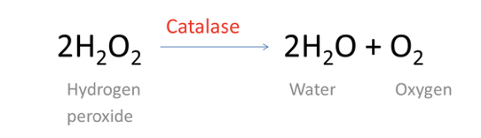

Although this reaction occurs spontaneously, enzymes increase the rate considerably. At least two different enzymes are known to catalyze this reaction: *catalase,* found in animals and protists, and *peroxidase*, found in plants. A great deal can be learned about enzymes by studying the rates of enzyme-catalyzed reactions. In this experiment, you will design an experiment to measure the rate of enzyme activity under various conditions.

At the start of the reaction, there is no product, and the pressure is the same as the atmospheric pressure. After a short time, oxygen accumulates at a rather constant rate. The slope of the curve at this initial time is constant and is called the *initial rate*. As the peroxide is destroyed, less of it is available to react and the O2 is produced at lower rates. When no more peroxide is left, O2 is no longer produced.

This investigation uses yeast encapsulated in spheres made of sodium alginate. Sodium alginate is a non-toxic hydrophilic polysaccharide that is used as a thickening agent in foods such as ice cream, yogurt, and cake mixes because it helps to emulsify oil and water and give a smooth texture to foods. It is used by some chefs to make flavor “pearls” or “caviar” and it is also used to encapsulate yeast in the production of wine. When sodium alginate, a hydrophilic polymer, comes in contact with CaCl2, sodium ions are replaced with calcium. This leads to cross-linkages between the polymer chains and an insoluble gel is formed.

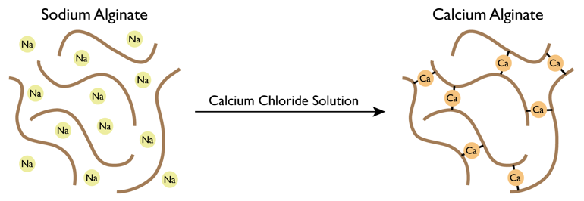

*From* [*https://scienceandfooducla.files.wordpress.com/2013/06/alginategelation1.png*](https://scienceandfooducla.files.wordpress.com/2013/06/alginategelation1.png)

**THE INVESTIGATION**

You and your partners will conduct an experiment that addresses the following concept:

**What factors affect enzyme activity?**

You and your group will need to refine your question to reflect the variable that you select to test.

**SAFETY CONSIDERATIONS**

* Wear safety goggles at all times.
* Wear closed-toe shoes during the lab.
* Do not eat or drink during the lab.
* Do not consume the yeast spheres.

**AVAILABLE MATERIALS:**

| * Yeast spheres (enzyme source) * Hot water bath * Ice * Stopwatch or timer * Ruler * Thermometer | * Hydrogen peroxide of varying concentrations (1.5%, 1.0%, .50%) * Water * styrofoam cups (to serve as a water bath) * 3 mL Syringe * Weigh trays (for yeast spheres) | * Transfer loops * Distilled water * Test tubes * Graduated cylinder * Test tube rack * pH buffers * Spoon |
| --- | --- | --- |

**YEAST/SPHERE PRODUCTION:**

**Preparing the yeast/sodium alginate solution:**

1. Add equal volumes of a 10% yeast (Saccharomyces cerevisiae) solution to a 2% sodium alginate solution (this solution is very viscous). Mix well with a glass rod. ***(20 ml of each, mix with end of inoculating loop)***
2. Draw up the yeast -sodium alginate solution into a 30 ml syringe or a plastic pipet (syringes give a little more control and consistency in size and can do more at once). Carefully wipe off all excess liquid from the syringe tip.

**Making the yeast spheres**

1. Hold the syringe or plastic pipet containing the yeast-sodium alginate solution over a beaker containing 50 ml of 0.15M CaCl2. ***(hold over plastic cup about 1/3 full with 0.15M CaCl2)***. Very slowly depress the plunger so that a drop of the yeast-sodium alginate solution falls into the beaker. A sphere should form as the drop comes in contact with the CaCl2 solution and falls to the bottom of the beaker.
2. Continue releasing yeast-sodium alginate drops into the 0.15M CaCl2 solution. Try to have spheres all of uniform size. The spheres should remain in this solution for about 5 minutes to harden.
3. Transfer the spheres using a spoon to a petri dish or beaker rinsing them with a squirt bottle of water. If not used immediately add 25 ml of water so the spheres don’t dry out.

**INVESTIGATION PROCEDURE:**

1. Select a variable to test from the following list:
   1. The concentration of enzyme (4 levels)
   2. The concentration of substrate (4 levels)
   3. pH (3 levels)
   4. Temperature (3 levels)
2. Create a data table in your BILL that reflects the independent and dependent variables for your investigation.
3. For your selected variable, you will do the following:
   1. Obtain a set of 10 yeast spheres. You will need more if you have selected enzyme concentration as the variable that you are testing.
4. For each of the variables we test, follow the directions below:
   1. **If your variable is pH, then you need to create a mixture of pH buffer and .50% hydrogen peroxide in 3 separate test tubes by doing the following:**
      1. Add 3 mL of pH buffer to 12 mL of hydrogen peroxide for each test you will conduct.
      2. Repeat this for each buffer that you test.
      3. You will also set up a test tube with 15 mL of distilled water.
      4. To test enzyme activity, use a transfer loop to drop a yeast sphere into each test tube. Time how long it takes the sphere to rise from the bottom of the test tube to the top of the liquid.
   2. **If your variable is the concentration of substrate, then you will set up 4 test tubes in a test tube rack:** 
      1. 15 mL of 0% hydrogen peroxide
      2. 15 mL of .50% hydrogen peroxide
      3. 15 mL of 1.0% hydrogen peroxide
      4. 15 mL of 1.5% hydrogen peroxide
      5. To test enzyme activity, use a transfer loop to drop a yeast sphere into each test tube. Time how long it takes the sphere to rise from the bottom of the test tube to the top of the liquid.
   3. **If your variable is temperature, you will set up 3 water baths in styrofoam cups and add test tubes containing 15 mL of .50% hydrogen peroxide**:
      1. One at room temperature
      2. One at a cold temperature
      3. One at a hot temperature
      4. To test enzyme activity, use a transfer loop to drop a yeast sphere into each test tube. Time how long it takes the sphere to rise from the bottom of the test tube to the top of the liquid.
   4. **If your variable is the concentration of enzyme, set up 4 test tubes in a test tube rack, each containing 15 mL of .50% hydrogen peroxide**:
      1. To test enzyme activity, use a transfer loop to drop a yeast sphere into the first test tube. Time how long it takes the sphere to rise from the bottom of the test tube to the top of the liquid.
      2. Repeat this process for 2 spheres, 3 spheres, and 4 spheres.

**Clean up your lab area by returning materials to the proper locations. Do NOT allow yeast spheres to be placed in the sinks.**

**THE DELIVERABLE: What You Will Turn In**

Your group will turn in a Science Writing Heuristics (SWH) for this lab on Canvas. Make sure to produce a QR code for your BILL. The research question for the lab is “**What factors affect enzyme activity?**